**Enlaces CanSat 2022/2023**

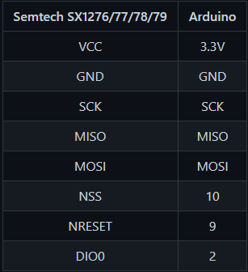LilyGo T-Beam:

<https://github.com/glacierjay/T_beam> ← Librerías + ejemplos (GPS y LoRa).

<https://github.com/LilyGO/TTGO-T-Beam> ← Más ejemplos.

<https://tinymicros.com/wiki/TTGO_T-Beam> ← Especificaciones técnicas.

Librerías:

<https://github.com/sandeepmistry/arduino-LoRa> ← Librería LoRa.

<http://arduiniana.org/libraries/tinygpsplus/> ← TinyGPS++

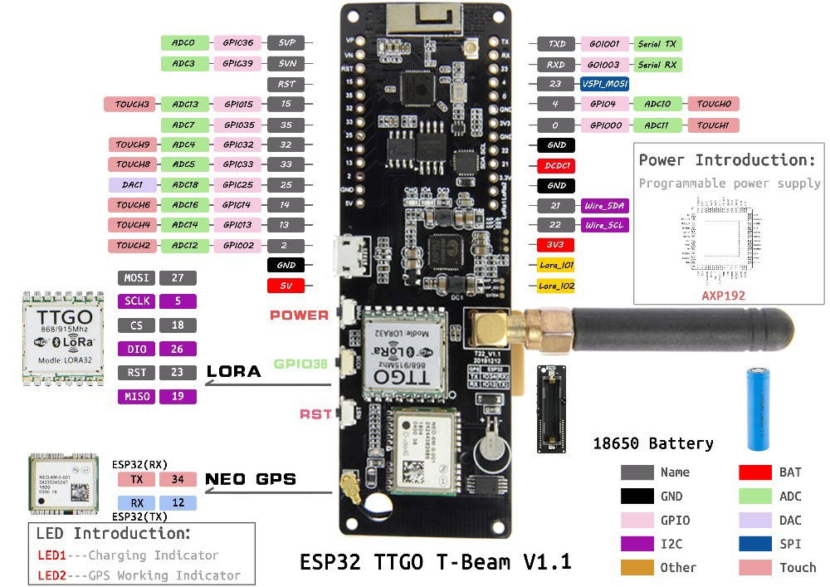

Problema GPS:

<https://meshtastic.discourse.group/t/t-beam-gps-problems-hardware/481/8> ← Tiene el mismo problema que nosotros.

<https://stackoverflow.com/questions/68083295/why-i-cant-get-gps-data-from-ttgo-tbeam-t22-v1-1-is-there-any-problem-with-my> ← Otro con el mismo problema (Enlace documento README)

<https://www.aeq-web.com/ttgo-lilygo-esp32-board-gps-signal-problem-ublox-neo-6/?lang=en> ← Solución te quiero

ESP32:

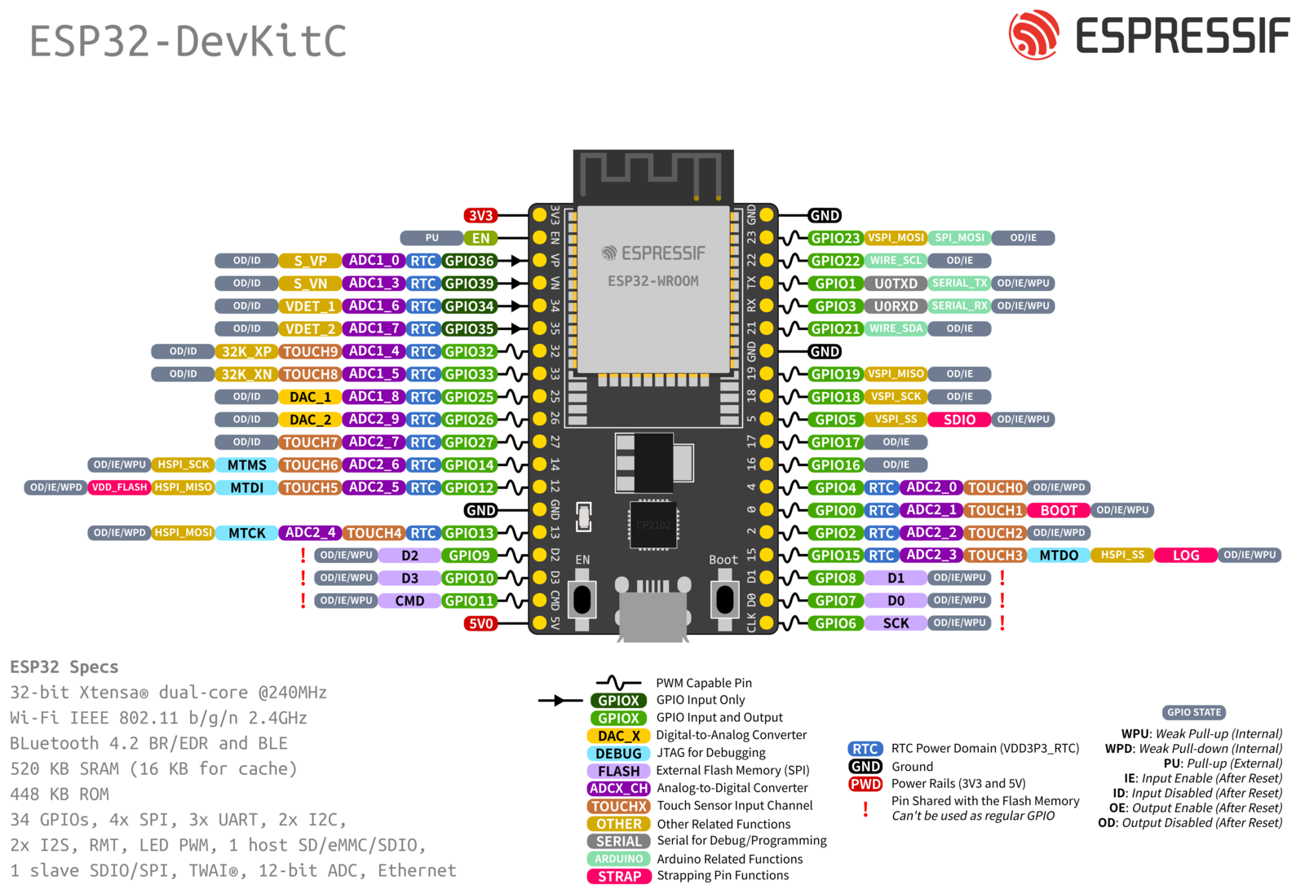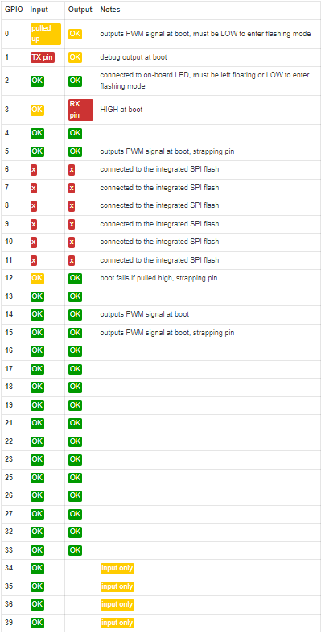

[PINOUT de la ESP32](https://randomnerdtutorials.com/esp32-pinout-reference-gpios/)

[Usando el LoRa con el ESP32](https://randomnerdtutorials.com/esp32-lora-rfm95-transceiver-arduino-ide/)

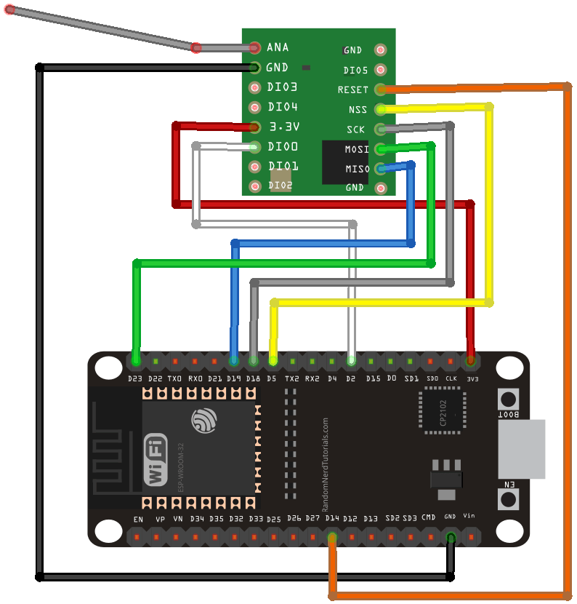

**Nota**: Usa los pines del VSPI por defecto.

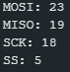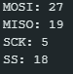

ESP 32 T-BEAM

<https://www.instructables.com/MPU6050-Setup-and-Calibration-Guide/>

gnd → GND

miso → 19

mosi →23 dio0 → 25

sck → 18 VCC → 5V

nss → 5

rst → 26

[Diferencias de char array vs String()](https://forum.arduino.cc/t/difference-between-char-array-and-string/603608/5)

[Limpiar array (Valores null)](https://arduino.stackexchange.com/questions/3167/clear-existing-array-when-getting-new-serial-command)

<https://javl.github.io/image2cpp/>

[sd problem](https://www.reddit.com/r/esp32/comments/j7jiyh/stuck_on_spi_with_the_ttgo_tbeam/)

[solucion (?) serial](https://forum.arduino.cc/t/arduino-esp32-import-error-no-module-named-serial/932371/5)

[solucion architecture](https://github.com/arduino/arduino-cli/issues/1590)

Problemas servo:

<https://forum.arduino.cc/t/servo-gone-crazy-moves-without-me-sending-command/74814/6>

<https://forum.arduino.cc/t/servo-moving-on-its-own/1015174>

* Probar librería servo en la arduino 1, el ejemplo “Sweep”, para comprobar y rastrear el error

[UI bonita](https://www.instructables.com/Design-a-Fancy-GUI-for-Your-Project/)

[Avion processing](https://www.reddit.com/r/arduino/comments/zreoc9/not_an_original_project_but_still_funny_to/)

<https://create.arduino.cc/projecthub/najad/interfacing-and-displaying-images-on-oled-59344a>

<https://diyusthad.com/image2cpp>

[Solución SD](https://github.com/Xinyuan-LilyGO/LilyGo-LoRa-Series/issues/41)

<https://www.circuitgeeks.com/oled-display-arduino/>